14 - 07 Feb 2023 (Kubernetes)

07 February 2023

20:35

Agenda:

1. Kubernetes
2. Container Orchestration using Kubernetes

# Container Orchestration

Helps to deploy the container across the multiple servers

Helps managing the dynamic nature of the container

Provides various benefits:

Requesting routing into multiple count

Provides desired state / auto healing

Scale up / down across the multiple servers

Multiple container orchestration tools

-Docker swarm - is from the docker org and its free (2%) [inbuilt featrue of docker software which we install, by default it is in inactive mode]

-Kubernetes - opensource / free (98%)

-OpenShift is licences version of Kubernetes developed by RedHat

Lab setup

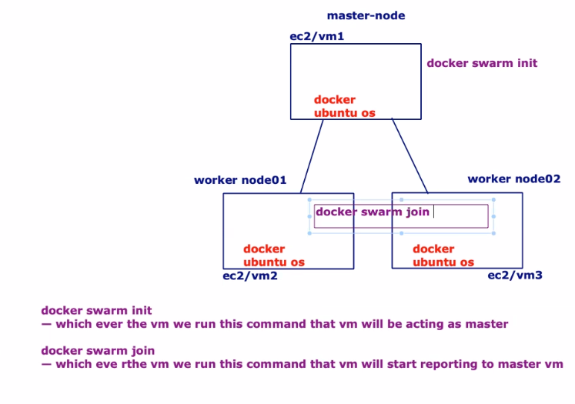

Create 3 EC2 images

Master-node

Worker-node1

Worker-node2

Master-node

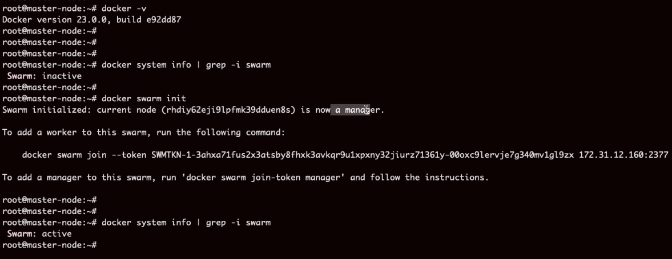

Workder-Node1



Worker-node2



Show worker node list

**docker node ls**

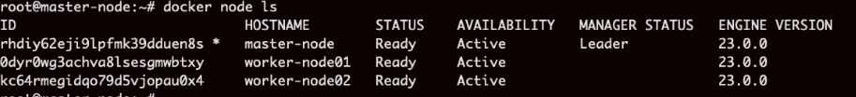

# How do we build a cluster?

Group of container is called a service.

In swarm we can create a service with cmd

docker service create --name myapp --replicas 7 -p 9080:3000 lerndevops/samples:pyapp-v2



Docker service --name testapp --replicas 5 9088:0 lerndevops:/samples:mywebsite-v1



# Where these VMs created?

docker service ls

Docker service ps myapp

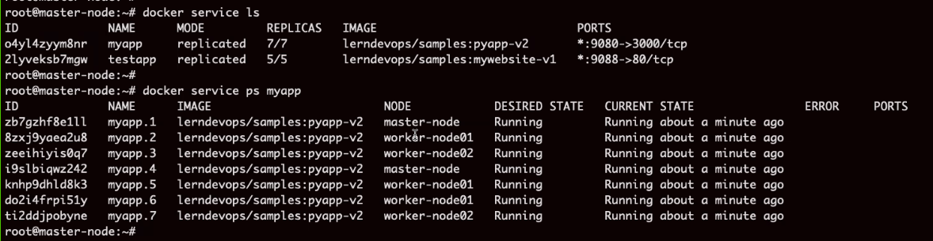

Scale up containers

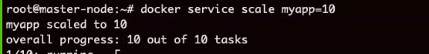

Scale down containers

No one uses Docker Swarm

Moving on to Kubernetes topic

# Kubernetes

It is container orchestration tool

Kube needs one of the containersation tool to be installed on the vms

Docker / crio / containerd / rocket

Kube is written using GoLang

Kube first release was in 2014

Lab

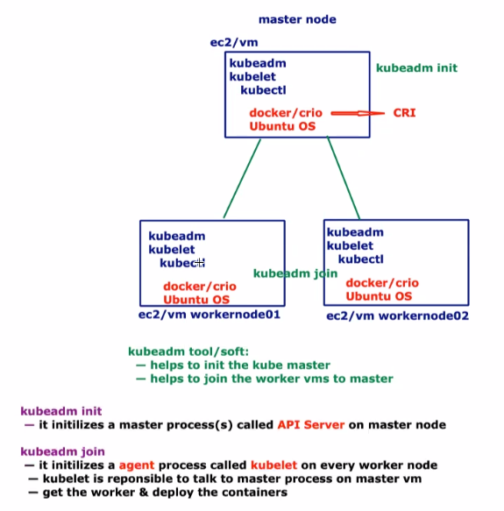

# kubectl is the command

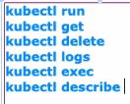

# Minimum hardware requirement

Spend extra on EC2, will cost 1 or 2 dollar per week

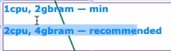

Docker system info | grep -I swarm

If swarm is active, we cannot use Kubernetes. Remove from master and worker nodes.

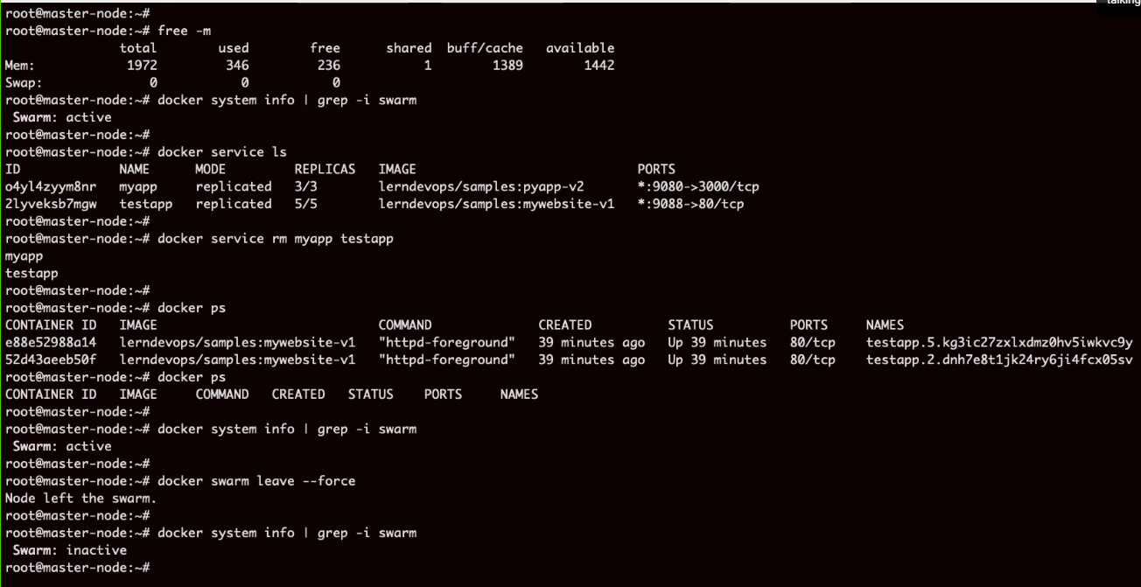

# Kubernetes practical

<https://github.com/lerndevops/educka/blob/master/1-intall/install-kubernetes-on-ubuntu-debian.md>

Install Kubernetes Using Script

Step1: On Master Node Only

## Install Docker

sudo wget <https://raw.githubusercontent.com/lerndevops/labs/master/scripts/installDocker.sh> -P /tmp

sudo chmod 755 /tmp/installDocker.sh

sudo bash /tmp/installDocker.sh

sudo systemctl restart docker

## Install kubeadm,kubelet,kubectl

sudo wget <https://raw.githubusercontent.com/lerndevops/labs/master/scripts/installK8S-v1-23.sh> -P /tmp

sudo chmod 755 /tmp/installK8S-v1-23.sh

sudo bash /tmp/installK8S-v1-23.sh

71 docker -v

72 kubeadm version -o short

73 kubelet --version

74 kubectl version --short --client

## Initialize kubernetes Master Node

sudo kubeadm init --ignore-preflight-errors=all

sudo mkdir -p $HOME/.kube

sudo cp -i /etc/kubernetes/admin.conf $HOME/.kube/config

sudo chown $(id -u):$(id -g) $HOME/.kube/config

## install networking driver -- Weave/flannel/canal/calico etc...

## below installs calico networking driver

kubectl apply -f <https://raw.githubusercontent.com/projectcalico/calico/v3.24.1/manifests/calico.yaml>

# Validate: kubectl get nodes

Step2: On All Worker Nodes

## Install Docker

sudo wget <https://raw.githubusercontent.com/lerndevops/labs/master/scripts/installDocker.sh> -P /tmp

sudo chmod 755 /tmp/installDocker.sh

sudo bash /tmp/installDocker.sh

sudo systemctl restart docker

## Install kubeadm,kubelet,kubectl

sudo wget <https://raw.githubusercontent.com/lerndevops/labs/master/scripts/installK8S-v1-23.sh> -P /tmp

sudo chmod 755 /tmp/installK8S-v1-23.sh

sudo bash /tmp/installK8S-v1-23.sh

71 docker -v

72 kubeadm version -o short

73 kubelet --version

74 kubectl version --short --client

## Run Below on Master Node to get join token

sudo kubeadm token create --print-join-command

copy the kubeadm join token from master & run it as sudo on all nodes

Ex: sudo kubeadm join 10.128.15.231:6443 --token mks3y2.v03tyyru0gy12mbt \

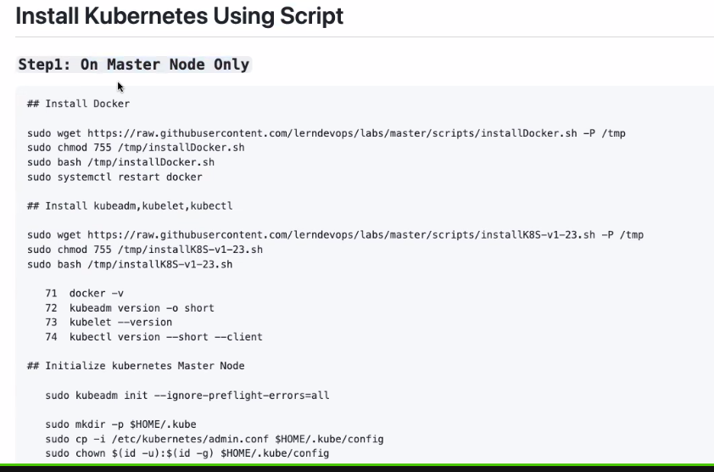

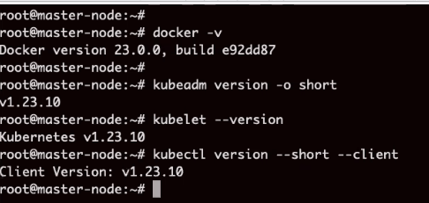

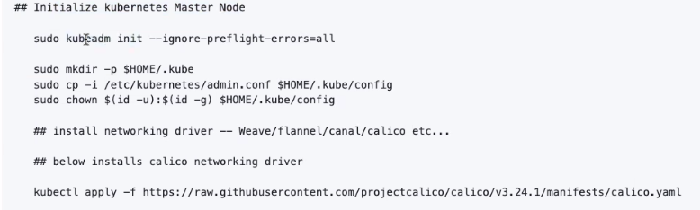

kubectl get nodes

Not ready yet

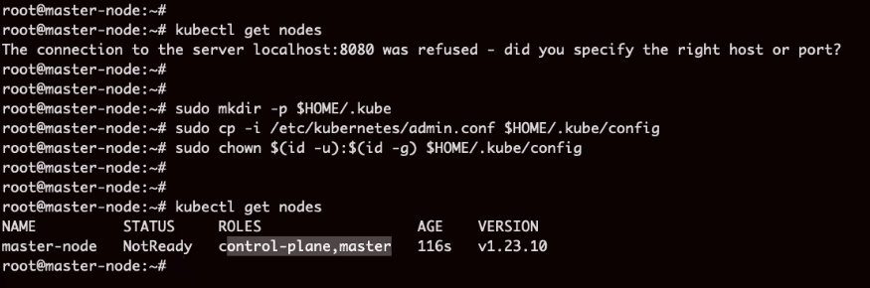

Run this command to make it ready



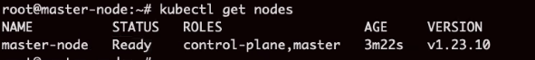

# On Worker node

**Step2: On All Worker Nodes:**

### INSTALL DOCKER   
   
 sudo apt-get update  
 sudo apt-get install -y apt-transport-https ca-certificates curl gnupg lsb-release software-properties-common  
 sudo mkdir -p /etc/apt/keyrings  
 curl -fsSL <https://download.docker.com/linux/ubuntu/gpg> | sudo gpg --dearmor -o /etc/apt/keyrings/docker.gpg  
 echo "deb [arch=$(dpkg --print-architecture) signed-by=/etc/apt/keyrings/docker.gpg] <https://download.docker.com/linux/ubuntu> $(lsb_release -cs) stable" | sudo tee /etc/apt/sources.list.d/docker.list > /dev/null

sudo apt-get update ; clear  
 sudo apt-get install -y docker-ce  
   
 sudo wget <https://raw.githubusercontent.com/lerndevops/labs/master/kubernetes/0-install/daemon.json> -P /etc/docker  
 sudo systemctl restart docker.service  
 sudo service docker status  
   
 ### INSTALL KUBEADM,KUBELET,KUBECTL

sudo apt-get update  
 sudo apt-get install -y apt-transport-https ca-certificates curl  
 sudo curl -fsSLo /usr/share/keyrings/kubernetes-archive-keyring.gpg <https://packages.cloud.google.com/apt/doc/apt-key.gpg>  
 echo "deb [signed-by=/usr/share/keyrings/kubernetes-archive-keyring.gpg] <https://apt.kubernetes.io/> kubernetes-xenial main" | sudo tee /etc/apt/sources.list.d/kubernetes.list  
 sudo apt-get update ; clear  
 sudo apt-get install -y kubelet=1.23.6-00 kubeadm=1.23.6-00 kubectl=1.23.6-00

## RUN Below on Master Node to get join token   
   
 kubeadm token create --print-join-command  
   
 copy the kubeadm join token from master & run it as sudo on all nodes  
   
 Ex: sudo kubeadm join 10.128.15.231:6443 --token mks3y2.v03tyyru0gy12mbt \  
 --discovery-token-ca-cert-hash sha256:3de23d42c7002be0893339fbe558ee75e14399e11f22e3f0b34351077b7c4b56

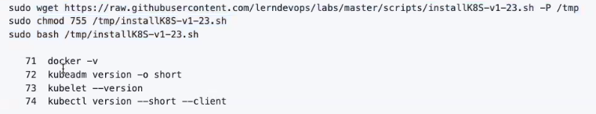

Check installation status

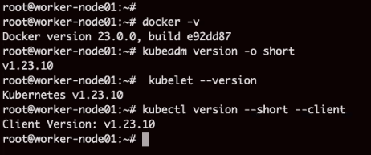

Check joino tock from master tiken

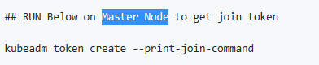



Past command in worker node



From master node check status of worker nodes

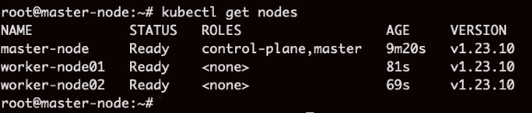

Worker node information

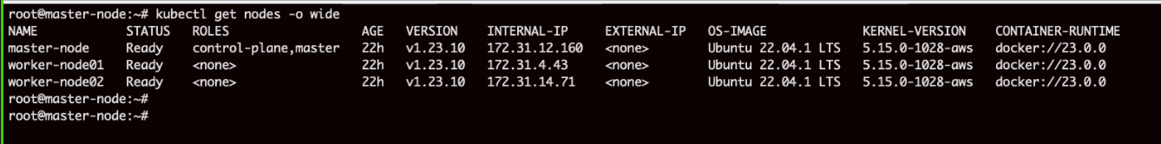

Tomorrow:

Home Work:

What is pod in kubernetes?

What is name space in kubernetes?

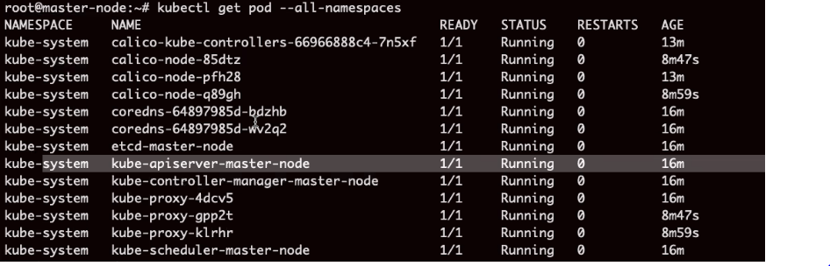

Practice

18 January 2023

16:14

cd /drives/c/Study/DevOps Training - Edureka

3.115.7.241

ssh -i edujan16.pem ubuntu@18.181.249.89

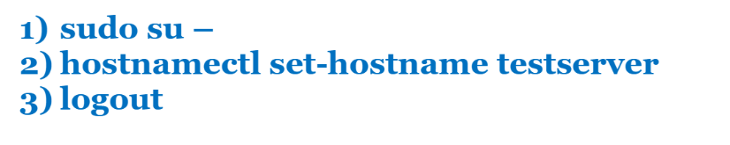

GitHub - <https://github.com/pradeepviswa/myproject.git>

Install GIT:

1 sudo apt-get install software-properties-common

2 sudo add-apt-repository ppa:git-core/ppa -y

3 sudo apt-get update

4 sudo apt-get install git -y

5 clear

6 history

7 git --version

8 ls -l /

9 clear

10 mkdir myproject

11 ls -l

12 cd myproject/

13 ls -l

14 ls -al

15 git init ## to initialize the local repo

16 ls -al

17 git config --global user.name pradeepviswa

18 git config --global user.email leaddevops@gmail.com

19 git config --global --list

20 ls -al

21 history

22 git status

